**Bomb Write Up/Instructions**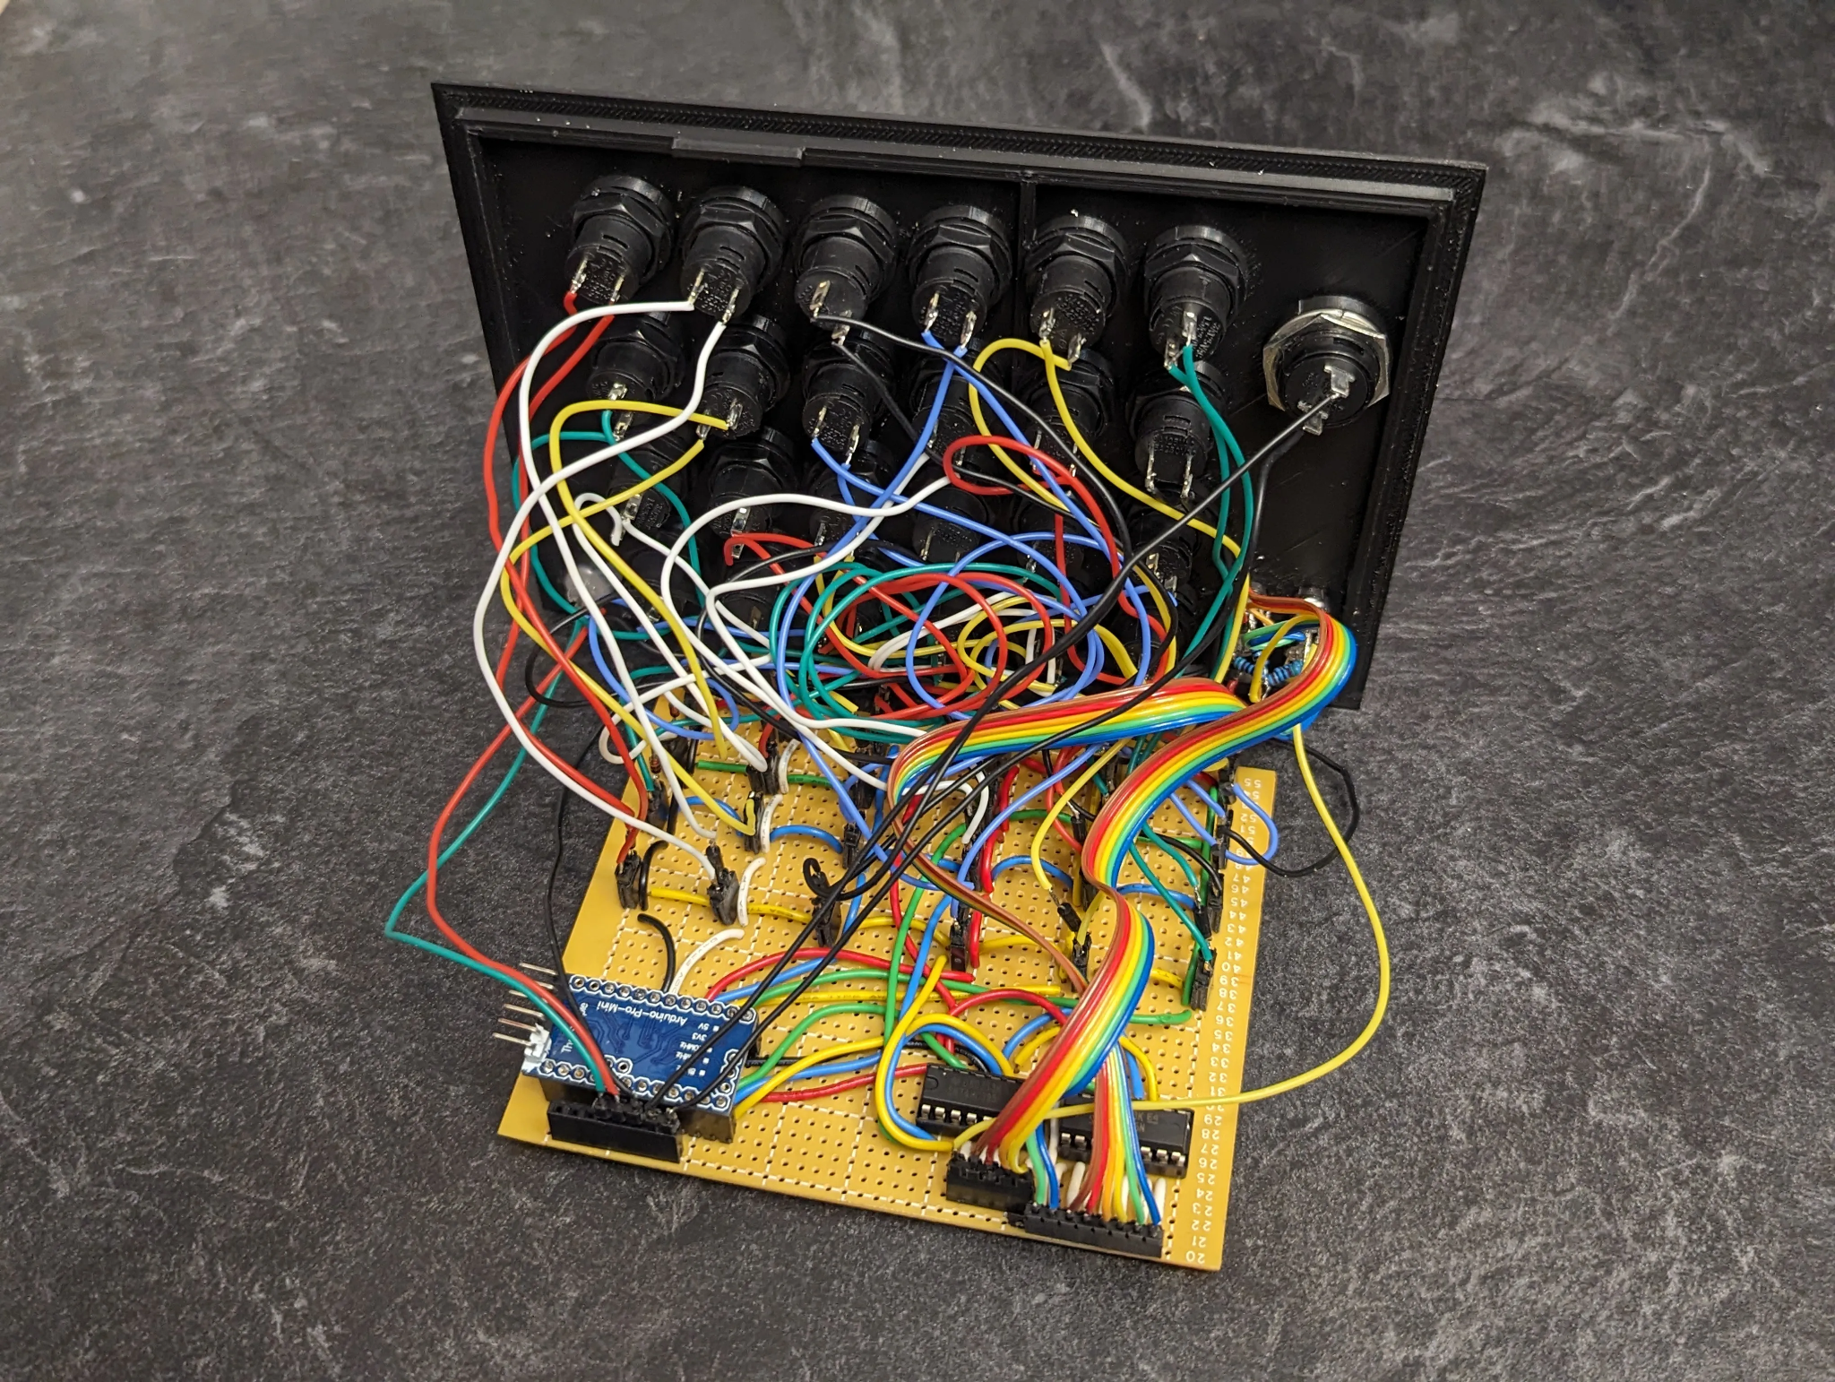

Starting off strong, we strive to have an aesthetically pleasing GUI while also maintaining its functionality. Ensuring our code works is the key ingredient to having a successful project. As we go through each component step by step, our main goal is to have unique and attention-grabbing factors to keep players entertained and wanting to keep playing.

**Button**

With the button, we decided to have it randomly pick a color which then corresponds to the number of times you have to click the button. Once they have noted the color, the user will then reflect this on how many times they will be pressing the button given in the manual.

**Keypad**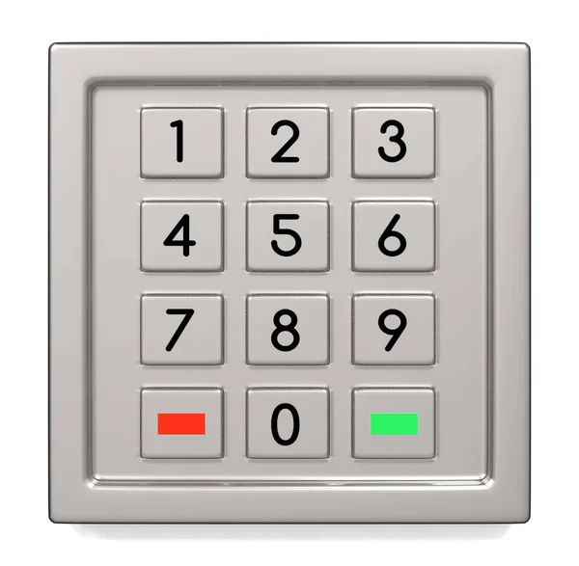

A user is given a riddle. Once the user has completed the riddle and figured out the answer, they are tasked to shift each letter right 5 times, giving the key letters needed. These letters will correspond to numbers on the keypad which the user will press in the correct order.

**Wires**

On the screen a phrase will be displayed with missing letters. The user, using this phrase, will pull wires out corresponding to the number space a letter is missing. For example, given the phrase “_om_” (Bomb), the user will figure out that the 1st and last wire will need to be pulled.

**Switches**

Displaying a hexcode equation in the manual, the user is tasked with solving this problem by converting it to binary which in turn corresponds to which switches need to be flipped based on a binary number determined from the equation. With 1 meaning that the switch is flipped on and with 0 meaning that the switch is in its regular position.

**Lessons Learned**

This project was a huge learning experience for all of us and tasked us to work together and overcome obstacles that came up. The main takeaway from this project for us was most likely the teamwork aspect. Getting hands-on experience and learning how to work in a group, especially using Github, was the most important. Seeing all the aspects that go into a group coding project really opened up our eyes to the world of coding and how it is in the real world.